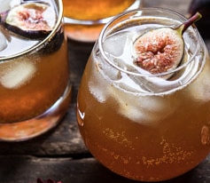
FIG, CIDER & TANGERINE SMASH
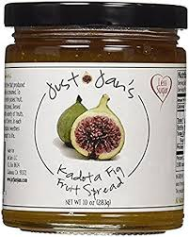
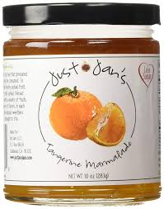

Ingredients
1/4 cup apple cider
1 teaspoon Just Jan’s Tangerine Marmalade
1 tablespoon Just Jan’s Kadota Fig Fruit Spread
2 ounces bourbon
1 teaspoon balsamic vinegar (optional, but delicious)
sparkling water, for topping

Instructions
1. In a cocktail shaker, combine the apple cider, orange zest, orange juice, fig preserves, bourbon, and balsamic vinegar, if using. Shake to combine.
2. Strain into a glass filled with ice. Top off with sparkling water and garnish with a fresh fig.

