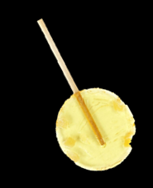
Honey Ginger Scotch Cocktail

Ingredients
- 2 1/4 ounces scotch
- 1/2 ounce lemon juice
- 1 Melville Candy Co. Ginger Lemon Honey Lollipop

Directions
- Combine scotch and lemon juice in an ice filled cocktail shaker and shake vigorously until frosted on the outside, between 15 and 25 seconds.
- Strain into a rocks glass with one, large ice cube.
- Insert lollipop and stir.

